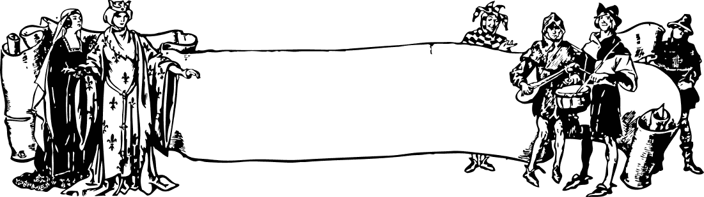
DRAFT

FORM 2
Short Story

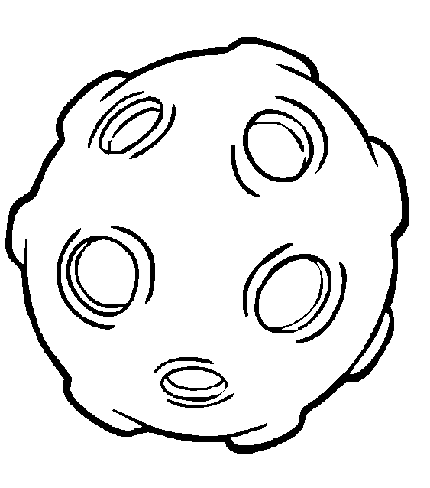
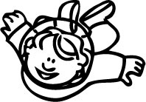
One is one and all alone


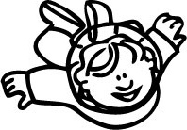
Table of Contents
Synopsis
Elements
Activities

Assessment
Answer Key
Glossary
Panel of writers





Curriculum Development Division.

Ministry of Education Malaysia
. 2010

ONE IS ONE AND ALL ALONE SHORT STORY
Synopsis

“One is One and All Alone” by Nicholas Fisk is a science fiction story, set in 2045. The main character is Trish, an 11-year old girl who is the only child on a spaceship to Trion. Her father is the Executive Officer of the spaceship and her mother is in Trion helping to set up a space station. She will only meet her mother in mid January 2047.

After three months, she feels lonely and bored as she does not have any real friends to talk to except her private, multi-functional diary: the VoicePrinter (VP). VP is an intelligent computer which keeps Trish entertained with its ability to perform many functions.

Through her dialogue sessions with VP, Trish learns about clones and the cloning process. The idea of cloning fascinates Trish and she soon decides to create a clone to keep her company in the spaceship Biolab without her father’s knowledge. She names her new identical twin “Clo” and initially it becomes her perfect friend and companion. They have fun playing and sharing their time together.

However, certain mannerism of Clo begins to irritate Trish as the clone behaves and thinks like her. Soon they start to argue and disagree with each other over trivial matters. The last straw happens one night when Clo starts referring to Trish’s mum as her mum and this upsets Trish as she feels her privacy is being invaded.

The next day, Trish opens up her diary and confides in VP that she does not like to be “swamped, invaded and taken over.” At that instant, she decides to dispose off Clo forever through the “DISPOSAL” hatch near her cabin.

The story ends with a twist when it is Trish who is disposed by Clo. Clo then assumes Trish’s identity and Trish’s dad is not aware of the change at all. Clo then enjoys being “one is one and all alone” and her new lease of life as Trish in the spaceship.

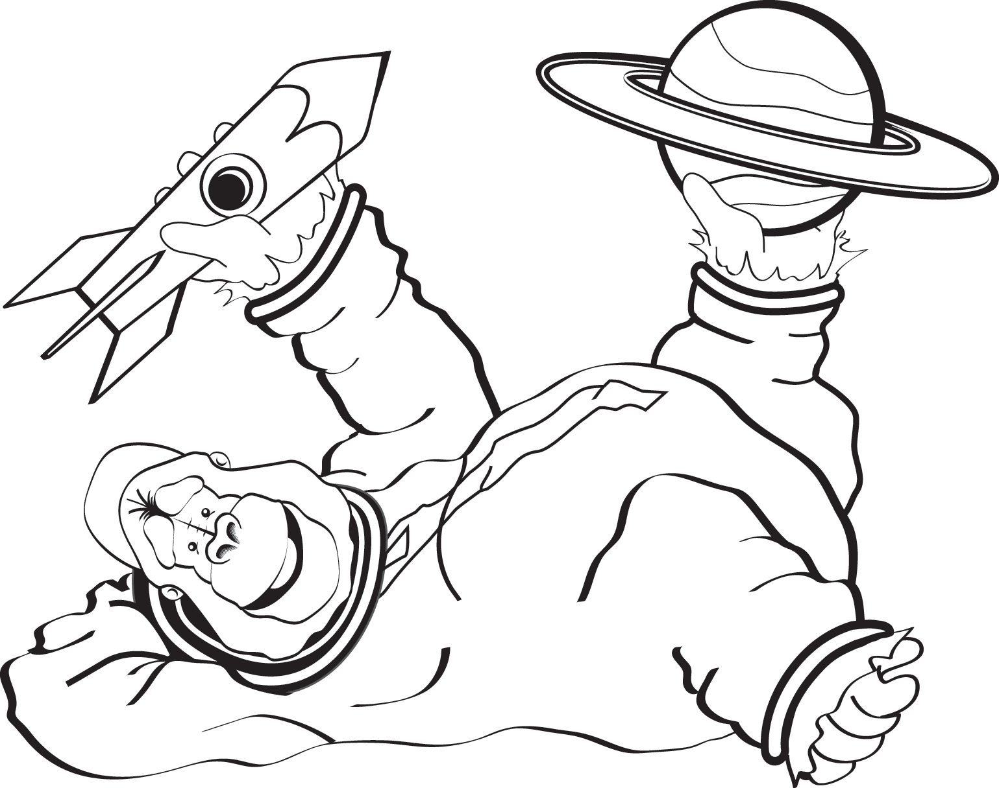

ONE IS ONE AND ALL ALONE SHORT STORY
Elements

SETTING

SOCIAL SETTING
Time
The story takes place in a spaceship which is in orbit in 2045 and will only
reach its destination, Trion, in 2 year’s time.



Period
The era of space exploration and advancement in computer technology
enable human cloning to become a reality.



PHYSICAL SETTING: SPACESHIP

Corridor
The passageways that run along the length of the spaceship.

Toilet/loo
Situated down the corridor where Trish and Clo accidentally saw themselves face to face.

Diner
Venue where Trish and her dad spend their time together having chocolate milkshakes.

Cabin
Trish’s personal living cubicle which is equipped with an intelligent computer called VoicePrinter (VP).

Biolab
A biology lab where ‘Clo’ was cloned.

Store
A room where basic necessities like toothbrushes, towels, etc are stored.

Disposal System
5 disposal hatches around the spaceship where unwanted things are disposed off into infinite space.



CHARACTER

Main character

11 years old; the only child on the spaceship heading towards Trion.

Lonely and bored.

Misses personal interactions with
her parents as her Dad is busy with his
work and Mum is away.

Relies on the VoicePrinter (VP) for companionship and information.

Intelligent: she masters the cloning technology
and created a clone of herself.

Short sighted as her cloning plan backfires.
Clo becomes a nuisance to her.

Clo in turn gets rid of Trish through the
Disposal Hatch instead.

Identical twin created by Trish in the
Biolab using cloning technology.

Trish’s friend and companion before she
‘got sick’ of her.

Quick thinking as she out
manoeuvres

Trish and gets rid of her creator.

Cautious, as she assumes Trish’s
identity at the end of the story.

Trish
Clo

Executive Officer of the spaceship.

Busy and preoccupied with work as
the captain of the spaceship.

Tries to spend time with Trish, his
daughter at the diner; indulging her
with chocolate milkshakes.

Does not realise that Trish has been
replaced by Clo at the end of the story.

Versatile and intelligent computer.

Tutor and companion to Trish in her
lonely days.

An avenue for Trish’s private thoughts, feelings and opinions.




Trish’s Dad
VoicePrinter

THEMES



Cloning
Trish clones herself in order to have a companion during her lonely days in the spaceship. However, her utopian plan backfires and in the end Trish is disposed off by ‘Clo’ and her place taken over by ‘Clo’.

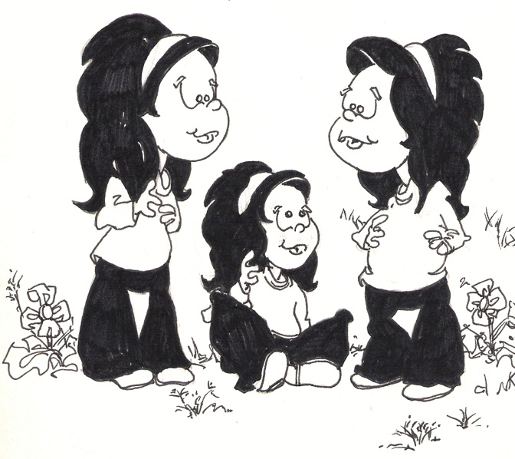
Friendship and companionship.
Being the only child on a spaceship with both her parents unable to spend time with her, Trish longs for friendship and companionship. The VoicePrinter cannot provide all her needs and she resorts to cloning to ‘make another Me’, so that she can have a friend and companion of her own age.


Loneliness
Despite having the latest technology around her, Trish feels “sick of computer images and sounds”. She wishes for someone to talk to, a companion to share her feelings and emotions. She longs for someone of her own age.


Science and Technology
The advancement of science and technology have led to an invention of a spaceship carrying humans to outer space. Trish has a VoicePrinter as a companion which she could communicate with. Through science and technology too, Trish succeeded in creating a clone of herself. Trish’s mother is busy setting up a space station on Trion.

VALUES

1. Family bonding

2. Think before you leap

3. Be thankful for what we have

4. Two wrongs do not make a right

5. Aware of our weaknesses and shortcomings


LITERARY DEVICES

Point of View

The story is told in the first person point of view. The first person narration enables the writer to vividly describe the actions and emotions of the characters in the short story. The readers have access to the thoughts and emotions of the main character, Trish, and later, Clo, after she murders Trish.

Style

A simple science fiction written as diary entries, in the form of dialogues. The diary entries allow us to get closer to the main character and her thoughts through simple and straightforward writing.

Repetition

“I’m sick of Me. I’m sick of being the only child on the ship. I’m sick of computer images and sounds” (p. 44)
“When Clo has nothing to do, it’s always pick, pick, pick” (p.48)

Trish repeats the word “sick” to emphasise her disappointment and frustration of being the only child on board the spaceship. She repeats the word “pick” to show her disgust of Clo’s irrirating picking habit.

Imagery

“Rolling bits of skin around a fingernail.” and “They writhe and fiddle all the time.”
(p. 48-49 – Para 1 – Line 6-8)

One can visualise what Clo is doing with her fingernails. One may find this an irritating habit. This obviously annoys Trish. However, looking at her age and her ability to understand, she fails to realise that Clo is just a mirror image of herself since they are both duplicates. By reprimanding Clo, she is indirectly reprimanding herself as she has the exact same habit. In fact, Clo points out, “Look – do you mind? Stop picking at yourself”

Irony

“I can’t stand the way Clo’s mind works. I can’t stand Clo’s corny jokes, and her dismal sulks. I can’t stand Clo’s laugh or eating habits or her finger picking”
(p. 52 – Para 2 – Line 2-4)

The irony of the situation above is, Trish finds Clo’s habits irritating and it begins to irk her. However, she fails to see that Clo’s habits are just a reflection of her own habits. Clo is her exact replica. Hence, Clo’s corny jokes, sulks, laughter and eating habits, the very things she can’t stand, are the things that she does herself. This is truly ironic. Trish may have created a clone but her immaturity in understanding this, brought about her own downfall.



ONE IS ONE AND ALL ALONE SHORT STORY

Plot

The plot in this story depicts some very interesting sequence of events. By analysing the important events in the story, one can better remember and understand the flow of the story.

❶ | In 2045, a spaceship is heading towards planet Trion. Being the only child onboard, Trish finds it difficult to adapt being all alone most of the time.
❷ | Her father, the executive officer on the spaceship, tries to spend time with her in spite of his busy schedule, while her mother was away in Trion.
❸ | Trish feels lonely and bored with only VP ( a VoicePrinter) as her playmate, tutor and friend. She yearns for human companionship.
❹ | Through VP, Trish gets an idea on creating a clone or making ‘another Me”. She secretly clones her own companion in the Biolab. She calls her identical twin “Clo”.
❺ | Initially Trish and Clo become good friends and have fun together. Trish begins to spend less time with VP as she is occupied with Clo.
❻ | Soon Trish begins to get tired of Clo as her mannerism which mirrors her, begins to irritate her. The breaking point is when Clo starts to refer to Trish’s mum as her own. This makes Trish really angry and she plans to ‘dispose’ off Clo forever through the disposal hatch system.
❼ | The story ends with a twist when the diary entry shows that Clo managed to turn the tables on Trish and disposed off her instead.
❽ | Clo assumes Trish’s identity and succeeds in deceiving Trish’s dad as well.
❾ | Clo then reminds herself that she needs to be Trish and enjoys her new identity and status onboard the spaceship.

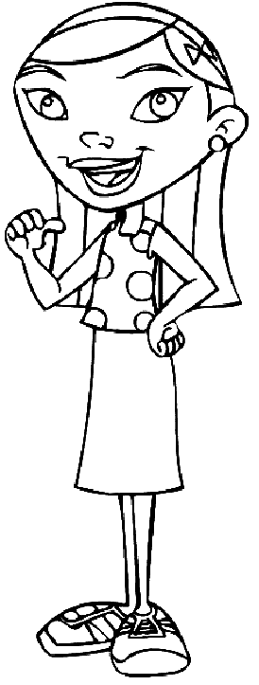
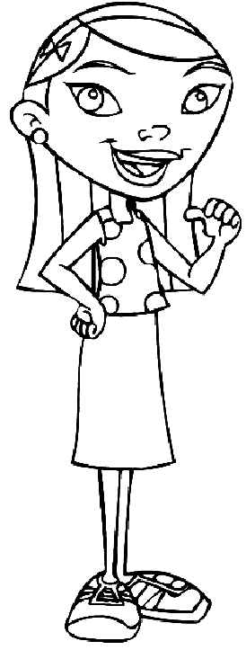

ONE IS ONE AND ALL ALONE PRE READING/ACTIVITY 1


Guess The Story

Time : 80 minutes


Aims
Materials
1 | Worksheet 1a

1 | To elicit students’ interests on the short story.
2 | To encourage students to predict the plot of the story.


Steps

1 | Teacher introduces the short story to students by displaying the title and the attached picture. (Worksheet 1a)
2 | Students imagine the plot of the story by referring to the picture and the accompanying questions. (Worksheet 1a)
3 | Students write out the plot in 5 sentences. (Worksheet 1b)
4 | Teacher discusses some of the plots that they have ‘created’.
5 | Students refer to their answers again after they have finished reading the story.
6 | Teacher draws on the students’ answers as the catalysts for the ‘epilogue’ discussion of the story.



Notes

For Lower English Proficency (LEP) students,
1) Teacher may guide them into writing the plot in the ‘prelude to the
story’s activity.
2) Teacher shows a series of pictures from the short story and students write
sentences based on the pictures. Use worksheet 1b

ONE IS ONE AND ALL ALONE PRE READING/WORKSHEET 1a

Guess The Story

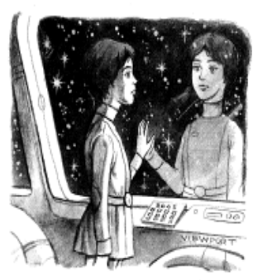

One is One and All Alone

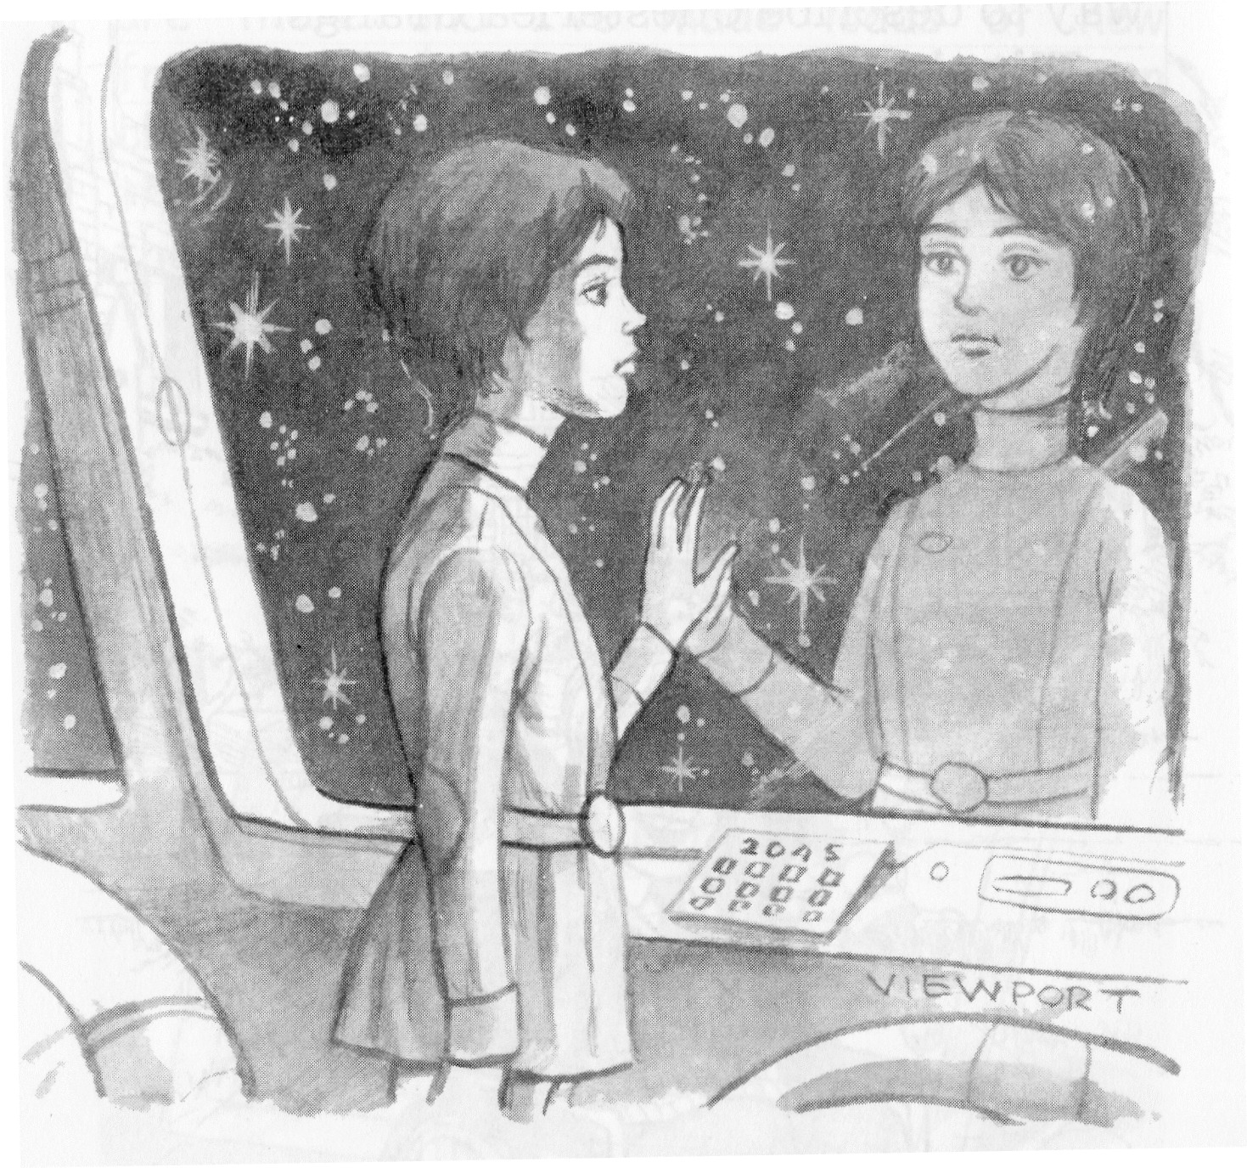

One is One and All Alone

Prelude to the short story
1. Based on the title, what do you think
the story is about? Write 5 sentences.

2. Based on the picture, what do you think the girl is thinking about?

Epilogue
1. Do you think the title is appropriate
for the story? Does it help you to
predict the story? Give reasons for
your answer.

2. If you were the writer, would you
change the title of the short story?
What would it be and why?



ONE IS ONE AND ALL ALONE PRE READING/WORKSHEET 1b

Guess The Story

Guess what the story is all about based o the pictures given.
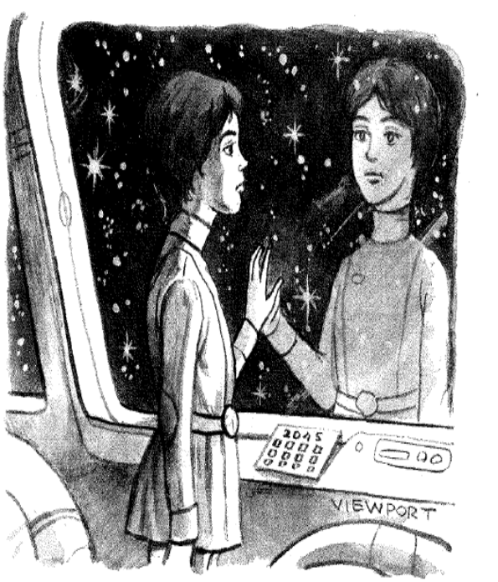

____________________________________

____________________________________

____________________________________

____________________________________

____________________________________

____________________________________

____________________________________

____________________________________

____________________________________

____________________________________

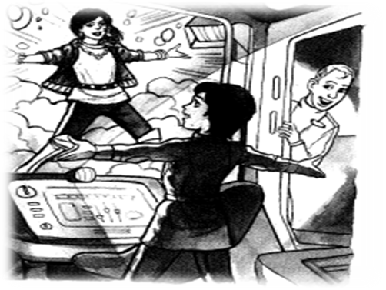

____________________________________

____________________________________

____________________________________

____________________________________

____________________________________

____________________________________

____________________________________

____________________________________

____________________________________

____________________________________

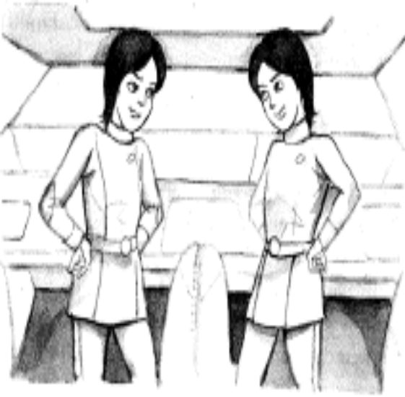

____________________________________

____________________________________

____________________________________

____________________________________

____________________________________

____________________________________

____________________________________

____________________________________

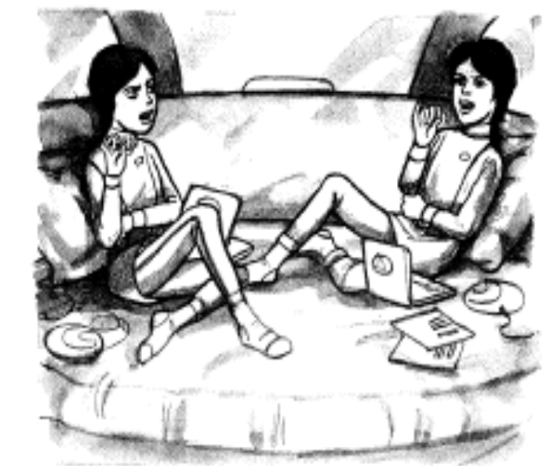

____________________________________

____________________________________

____________________________________

____________________________________

____________________________________

____________________________________

____________________________________

____________________________________

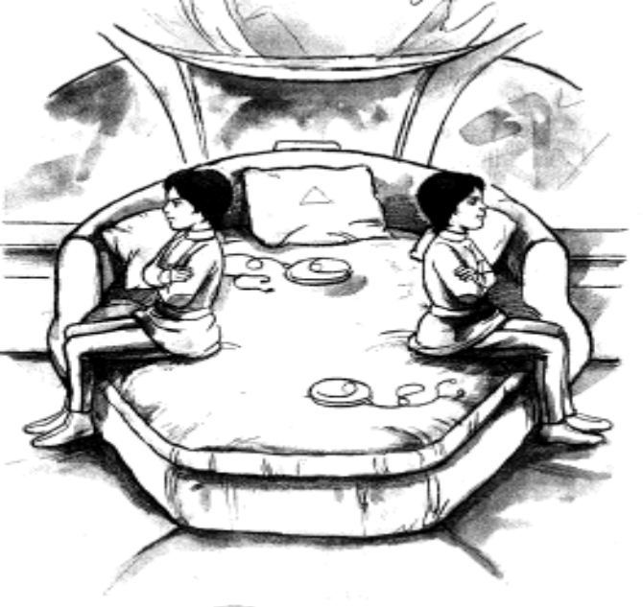

____________________________________

____________________________________

____________________________________

____________________________________

____________________________________

____________________________________

____________________________________

____________________________________

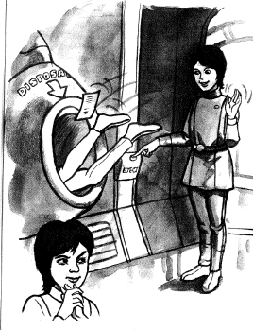

____________________________________

____________________________________

____________________________________

____________________________________

____________________________________

____________________________________

____________________________________

____________________________________

____________________________________

____________________________________

____________________________________

____________________________________

____________________________________

____________________________________

____________________________________

____________________________________

____________________________________

____________________________________

____________________________________

____________________________________

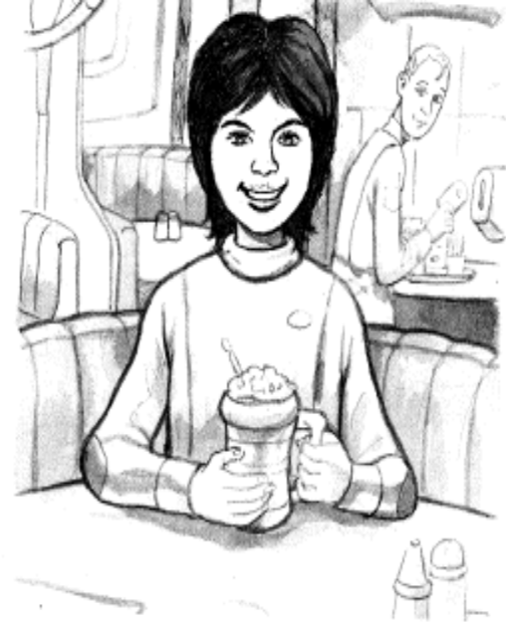



ONE IS ONE AND ALL ALONE SETTING/ACTIVITY 2

Trion

Time : 40 minutes
Aims
Materials

1 | To match different settings with the correct descriptions.
2 | To place different settings in the spaceship.

1 | Worksheet 2

Steps

1 | Elicit different settings in the short story.
2 | Students verbally describe each setting.
3 | Distribute the worksheets.
4 | Students match settings in the picture.
5 | Teacher recaps settings in the short story.

Notes

Students can also look for textual evidence from the text to support the information and description given in the picture by producing a specific page number. This activity will enhance students’ skimming and scanning skills.

ONE IS ONE AND ALL ALONE SETTING/WORKSHEET 2

Trion

Match the following descriptions to the blanks.

A | 2045 – Era of Space Exploration | E | A personal room
B | A place where Trish and dad have their chocolate milkshakes | F | Port-of-call for the spaceship in 2047
C | A place where unwanted things are dumped into space | G | Where Trish and Clo bumped into each other
D | An area where supplies are kept | H | Where Trish created her clone

8. Loo - ______

1. Year - ______ 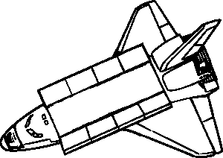
6. Disposal Hatch - ______
7. BioLab - _______


3. Store - ______ 4. Cabin - ______
5. Diner - ______
2. Trion - ______

ONE IS ONE AND ALL ALONE SETTING/ACTIVITY 3

Lonely I Am…

Time : 40 minutes
Aims
Materials

1 | To be able to identify settings of the story.
2  3 | To help students comprehend the settings of the story better.  To identify Trish’s moods and feelings in the story

1 | Worksheet 3

Steps

1 | Teacher explains different types of settings.
2 | Teacher distributes worksheets.
3 | Students provide answers to the topic.
4 | The students complete the task with close reference to the text.
5 | The students deliver a short presentation.

Notes

The setting refers to the geographical location (place), the time and the general environment and circumstances that prevail in a narrative. The setting helps to establish the mood of a story

ONE IS ONE AND ALL ALONE SETTING/WORKSHEET 3

Lonely I Am…

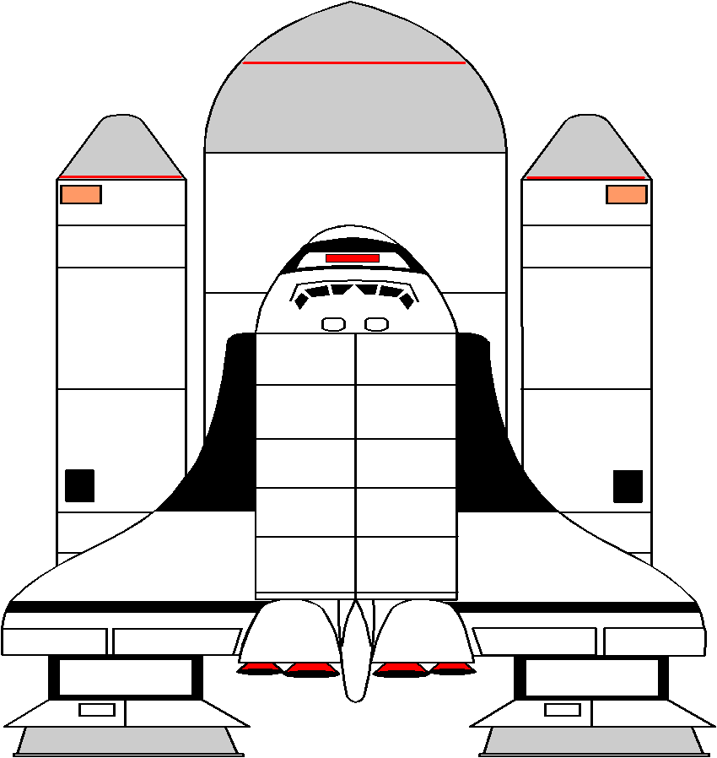

PERIOD
2047 – Advancement in science & technology

PHYSICAL SETTING / FEELINGS
1. Diner – Brings wonderful memories of the good times with her dad
2.
3.
4.

TRISH’S MOOD AND FEELINGS
Pre-cloningPost-cloning

ONE IS ONE AND ALL ALONE CHARACTERISATION/ACTIVITY 4

Character Traits

Time : 40 minutes
Aims
Materials
1 | Worksheet 4a and 4b

1 | To identify adjectives.
2 | To use adjectives correctly.
3 | To explore new vocabulary.

Steps

1 | Get students to describe a friend. Point out the adjectives used in the description.
2 | Teacher explains the meaning of “Adjectives” and brainstorm for answers.
3 | Teacher distributes worksheet 4a and 4b.
4 | Students find suitable adjectives from Worksheet 4a and use them to complete Worksheet 4b.
5 | Students share findings with their partner.
6 | Teacher discusses the answers.

Notes

Adjectives are words which tell us more information about nouns.
Adjectives are also used to show comparison. It can be in the comparative and superlative forms. Some adjectives form their Comparative and Superlative with “more” and “most”. Some comparisons are irregular.

As homework, students construct five sentences using the adjectives that they found from the Adjective Hunt handout

ONE IS ONE AND ALL ALONE CHARACTERISATION/WORKSHEET 4a

Adjective Hunt

Hunt for the adjectives in the word maze below and fill in the appropriate boxes.
I | N | D | U | L | G | I | N | G
N | V | T | J | O | R | N | B | O
F | E | R | B | N | J | D | U | P
O | R | U | O | E | F | E | S | T
R | S | E | L | L | B | P | Y | I
M | A | Q | D | Y | R | E | K | M
A | T | C | A | R | I | N | G | I
T | I | W | G | H | G | D | Q | S
I | L | Y | R | X | H | E | T | T
V | E | L | T | Z | T | N | L | I
E | O | S | M | A | R | T | Y | C
C | O | N | C | E | R | N | E | D
F | A | I | T | H | F | U | L | M

ONE IS ONE AND ALL ALONE CHARACTERISATION/WORKSHEET 4b

Character Traits

13.
1.

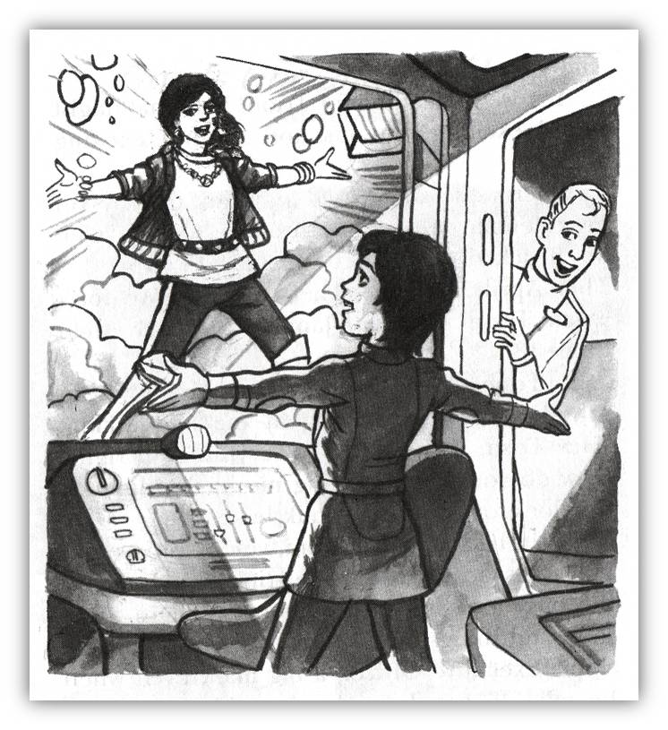

VoicePrinter
2.
12.

Dad
3.
11.

4.
10.

9.
Trish
5.

8.
7.
6.

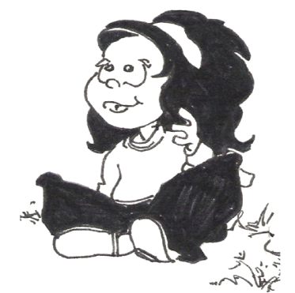

ONE IS ONE AND ALL ALONE CHARACTERISATION/ACTIVITY 5

Trish & Clo

Time : 40 minutes
Aims
Materials
1 | Pictures of famous twins
2 | Worksheet 5a

1 | Students identify changes in Trish’s character prior to and after the cloning process.
2 | Track changes in Trish’s character traits in the development of the story.
3 | Elicit students’ personal response on Trish’s decision to opt for cloning.

Steps

1 | Teacher shows the pictures of famous twins to start off the lesson.
2 | Students name and give a brief description of the twins.
3 | Teacher introduces the issue of cloning.
4 | Teacher guides the students on the development of Trish’s character (prior to and after the cloning process).
5  6  7 | Students list out Trish’s character traits in both stages of her life.  Students state their opinions on cloning in Worksheet 5b.  Some students present their viewpoints.

Notes

ONE IS ONE AND ALL ALONE CHARACTERISATION/WORKSHEET 5a

Trish & Clo

Famous Twins



Mary-Kate Olsen and Ashley Fuller Olsen



Aidil Zaquan and Zafuan Adha Robert Bryan and Michael Bryan

ONE IS ONE AND ALL ALONE CHARACTERISATION/WORKSHEET 5b

Trish & Clo

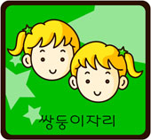



Trish Clo

Pre-Cloning

1. Mature for her age

2. Lonely

3. Intelligent

4. Single-minded

5.

6.

Post-Cloning

1. Sense of humour

2. Short-sighted

3.

4.

5.

6.

Do you agree with Trish’s decision in creating a clone as a companion? Provide reasons for your answer.

ONE IS ONE AND ALL ALONE CHARACTERISATION/ACTIVITY 6

Contextual Evidence

Time : 40 minutes
Aims
Materials

1 | To identify the key traits of the character.
2 | To help students understand the characteristics by justifying their reasons supported with contextual evidence.

1 | Worksheet 6
2 | Crayons & Colour Pencils

Steps

1 | Teacher distributes Worksheet 6.
2 | Students draw the chosen character from the short story.
3 | Students write the character’s name below the illustration.
4 | Students write one character trait that the character possesses in the “Trait” bubbles.
5 | Students support their character traits with textual evidence.
6 | Students present their findings.

Notes

Character traits are words which give more information
about the characters in a short story.

ONE IS ONE AND ALL ALONE CHARACTERISATION/WORKSHEET 6

Character Sketch

Draw a character from the short story, ‘ONE IS ONE AND ALL ALONE’. In each bubble, write a trait that this character possesses. Find the textual evidence from the story to support your answer.

Character Name : __________________________
  
Trait
Trait
Trait

Textual Evidence

Page :

Textual Evidence

Page :

Textual Evidence

Page :



ONE IS ONE AND ALL ALONE CHARACTERISATION/ACTIVITY 7

E-mail to Mum

Time : 40 minutes
Aims
Materials
1 | Worksheet 7

1 | To be able to write an e-mail.
2 | To enable students to understand Trish’s predicament.

Steps

1 | Teacher conducts a brainstorming session to recap on students’ knowledge on the short story.
2 | Teacher highlights the key events and Trish’s emotional state at that time in the story.
3 | Teacher distributes Worksheet 7.
4 | Students are to assume Trish’s role and write an e-mail to her mother about the problems that she face on the spaceship.

Notes

The teacher asks part of the class to assume the role of Trish’s mother and reply their classmates’ email as further extension of the activity.
Take students to the computer lab to write the email.

ONE IS ONE AND ALL ALONE CHARACTERISATION/WORKSHEET 7

E-mail to Mum

Trish is feeling lonely on board the spaceship. Her father is too busy handling matters regarding the spaceship. Imagine you are Trish and you decide to write an email to your mother on planet Trion to explain about your situation and seek her advice. Use the space below to write your email.
......................................................................................................................
To | : | Mum

From | : | Trish

Subject | :

______________________________________________________________________

______________________________________________________________________

______________________________________________________________________

______________________________________________________________________

______________________________________________________________________

______________________________________________________________________

______________________________________________________________________

______________________________________________________________________

______________________________________________________________________

______________________________________________________________________

______________________________________________________________________

______________________________________________________________________

______________________________________________________________________

______________________________________________________________________

______________________________________________________________________

ONE IS ONE AND ALL ALONE PLOT/ACTIVITY 8

The Hatch

Time : 40 minutes
Aims
Materials
1 | Worksheet 8

1 | To develop students’ creativity and imagination skills in solving a murder mystery.
2 | To develop students’ abilities to construct sentences using the given key words.
3 | To enable the students to trace out the plot of the story in a creative way.

Steps

1 | Teacher introduces the crime scene to the students.
2 | Students play the role of a Crime Scene Investigator.
3 | Teacher explains the students’ role as a CSI.
4 | Teacher distributes Worksheet 8 and guides the students through the clues provided.
5 | Students carry out their investigation by using the clues and key words provided.
6 | They write their version of the incident in a report to the Executive Officer of the spaceship.

Notes

For extension activity, students role play the scenes leading to the crime.

ONE IS ONE AND ALL ALONE PLOT/WORKSHEET 8

The Hatch


DISPOSAL

Goodbye, Trish.
Happy memories, I don’t think.
Yours never, Clo.

EJECT

Imagine you are a Crime Scene Investigator on the space ship. You heard rumours saying that Trish was murdered and her body was disposed in a disposal hatch. You found some of her personal belongings and a note at the mouth of the hatch. The note stated “Goodbye Trish. Happy memories, I don’t think. Yours never, Clo”. Based on the evidence gathered at the scene, write a description of the incident to the Executive Officer.

“Trish”
Cloning
Biolab
“Clo”

behavior
Irritating
angry
hate

get rid
Disposal Hatch
Corridor
murder

ONE IS ONE AND ALL ALONE PLOT/ACTIVITY 9

Story Map

Time : 80 minutes
Aims
Materials
1 | Worksheet 9

1 | To help students to reproduce the plot.

Steps

1 | Teacher distributes Worksheet 9 to students.
2 | Students are grouped into groups of 4.
3 | Students discuss the whole story and to fill in the story map with relevant details.
4 | Teacher pastes each group’s work and a representative from each group will present their findings.
5 | Students will move around to look at other group’s work.
6 | Teacher summarises the story.

Notes

For Lower English Proficiency classes, the teacher provides answers and students can match them to the diagram.

ONE IS ONE AND ALL ALONE PLOT/WORKSHEET 9

Story Map

Complete the Story Map with important events from the short story.

Title of the story : _____________________________________________

After the VoicePrinter (VP) informs her about cloning, _________

_______________

_______________

_______________

_______________


❷

❻

The story ends when

___________________

___________________

___________________

___________________

The story begins when Trish feels lonely aboard the spaceship heading towards Trion. _________

______________

______________

______________

❶

Next, Trish and Clo enjoy their fellowship together. ________

_______________

_______________

_______________

_______________
❸


She tries to solve the problem by ______

_______________

_______________

_______________

_______________

_______________

Then Trish becomes irritated at Clo’s manners and behaviours. _______

____________________

____________________

____________________

_______________

❺
❹

ONE IS ONE AND ALL ALONE THEMES/ACTIVITY 10

Human Cloning

Time : 240 minutes
Aims
Materials
1 | Worksheets 10a & 10b.
2 | Reading materials on the issue.

1 | To gather information about cloning from the Internet, magazines and newspapers.
2 | To be able to substantiate points with concrete facts.
3 | To participate in a short debate.

Steps

1  2  3 | Students research on the issue of human cloning prior to lesson.  Teacher shows a picture of “Dolly The Sheep”.  Teacher elicits responses from students on the picture.
4 | Students gather information on the advantages and disadvantages of human cloning (Worksheet 10a)
5 | Organise students into two groups: the Opposition and the Government.
6  7 | Teacher distributes Worksheet 10b and instructs the groups to brainstorm and fill in their arguments  Teacher reads the rules and distributes reading materials

Notes

This activity can be turned into a normal classroom discussion if the class consists of Lower English Proficiency students. Assist them by asking ‘WH’ questions which will help them to comprehend the issue better.
For High English Proficiency classes, the teacher elects a chairperson, time keeper and adjudicators. Students debate on the issue.

ONE IS ONE AND ALL ALONE THEMES/WORKSHEET 10a

Human Cloning

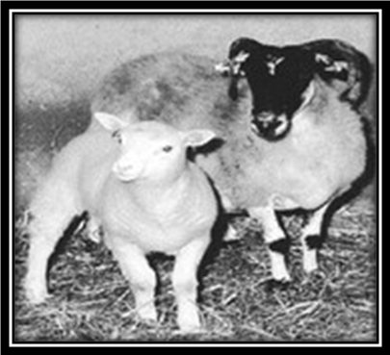
A lamb, genetically identical to the donor sheep.
Donor sheep


Imagine you have the facilities to conduct cloning. What is your stand on the issue?

1.

2.

3.

4.

1.

2.

3.

4.

Advantages

Disadvantages

ONE IS ONE AND ALL ALONE THEMES/WORKSHEET 10b

Human Cloning


Human cloning should be legalised.
What is your stand?

These are some of the points that you can use to support your stand.
Find more points and ideas from the story. Brainstorm with group members and also use information from other resources, such as the Internet. Add more points to the list and provide elaboration for all these points.

The advantages of human cloning according to the story


1. “Perfect friend and companion” (p. 46)

2. “Clo is me. I am Clo. We are identical twins. No, even closer
than that. Clo is made of me, from me” (p. 47)

Other advantages of human cloning


1. Obtain organs for transplant

2.

3.

4.

5.

6.

Human cloning should not be legalised.

These are some of the points that you can use to support your stand.
Find more points and ideas from the story. Brainstorm with group members as well
as from other resources, such as the Internet. Add more points to the list and provide
elaboration for all these points.

The disadvantages of human cloning according to the story


1. “I don’t want to share everything: some thoughts
are private.” (P. 51)

2. “I now need two of everything – but the ship is loaded with
stores” (p. 48)

Other disadvantages of human cloning


1. Killing of clones for internal organs

2.

3.

4.

5.

6.

ONE IS ONE AND ALL ALONE THEMES/ACTIVITY 11

Tell me the themes!

Time : 40 minutes
Aims
Materials
1 | Worksheet 11

1 | To identify the themes in the story.

Steps

1 | Teacher elicits the themes of the short story.
2 | Students support the themes with evidence from the short story.
3 | Teacher assists the students as they discuss on the themes of the short story.

Notes

Students can work in pairs or groups.

ONE IS ONE AND ALL ALONE THEMES/WORKSHEET 11

Tell me the themes!

Write out two themes you have found from the “One in One and All Alone”. Provide evidence from the story to support your answer. Use the graphic organiser to complete your task.

Theme: ______________________________________________________________
Evidence from the text

1._______________________________________________________________

_______________________________________________________________

2._______________________________________________________________

_______________________________________________________________

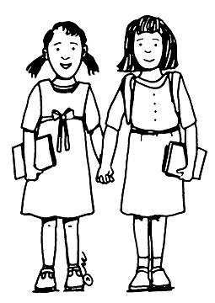

Theme: ______________________________________________________________
Evidence from the text

1._______________________________________________________________

_______________________________________________________________

2._______________________________________________________________

_______________________________________________________________

ONE IS ONE AND ALL ALONE VALUES/ACTIVITY 12

Moral Values

Time : 80 minutes
Aims
Materials
1 | Worksheet 12
2 | A pair of scissors

1 | To identify moral values in the short story.

Steps

1 | Teacher cuts out the moral value cards and distributes one card to each group (Worksheet 12).
2 | Students provide evidence from the short story to support the given moral values.
3 | Each group creates a two or three minute scene that illustrates the meaning of the moral value. Students carry out a game of charade or mime based on the scene that depicts values in the novel.
4 | When each group have presented, ask the class to guess the moral values. Offer prompts until someone states the correct moral value for each presentation.

Notes

Remember not to be confused between moral values and theme.

ONE IS ONE AND ALL ALONE VALUES/WORKSHEET 12

Moral Values



THE MORAL OF THE STORY

Look before you leap
Family bonding

Be thankful for what we have
Two wrongs do not make a right

Aware of our weaknesses and shortcomings

ONE IS ONE AND ALL ALONE LITERARY DEVICES/ACTIVITY 13

Figuratively speaking

Time : 40 minutes
Aims
Materials
1 | Worksheet 13

1 | To recognise the important literary devices.
2 | To match the literary device with its correct description.

Steps

1 | Teacher explains the different literary devices in a short story.
2 | Teacher provides some explanations and examples on literary devices
3 | Teacher distributes Worksheet 13.
4 | Students match the literary devices with their correct description.
5 | Class discussion on students’ findings.
6 | Teacher provides more examples of literary devices to further enhance their understanding.

Notes

For Lower English Proficiency classes, teacher can list out the literary devices.

ONE IS ONE AND ALL ALONE LITERARY DEVICES/WORKSHEET 13

Figuratively speaking

Unscramble the following words and match the given statements to the correct literary device.

ieimls

“Me, a picker! I never pick at my fingers”

iwtst idngen
“There are a thousand things on his mind.”(pg 41)
“It’s like being swamped, invaded, taken over.” (pg 52)

drow nilooccato

“… bright as a button” (pg 54)

leinolatrtai
“Yum-yum!” (pg 55)
“The hatch went whoosh! (pg 56)

stcnoatr
“I must remember from now on – my name.” (pg 56)

ryino
“Finished and forgotten” (pg 54)
“Finally free” (pg 54)

tiepnoitre
“Now that might sound exciting, but it’s not”(pg 41)

getinoxegara
“Saw 2 Trishes instead of one!” (pg 47)
“We stared at each other, eyes and mouths wide open” (pg 48)

uosdn emsiag
“When Clo has nothing to do, it’s always pick, pick, pick”. (pg 48)

asuivl emsiag
“split second” (pg 47)
“train of thought”(pg 51)

ONE IS ONE AND ALL ALONE ASSESSMENT/ACTIVITY 14

Have I understood?

Time : 40 minutes
Aims
Materials
1 | Worksheet 14

1 | To be able to answer 10 comprehension questions.
2 | To check students’ understanding of the important events in the story.

Steps

1 | Teacher distributes Worksheet 14.
2 | Students identify the correct answer.
3 | Teacher discusses the answers, highlighting the important details and events of the story.

Notes

Lower English Proficiency students can work in pairs.

ONE IS ONE AND ALL ALONE ASSESSMENT/WORKSHEET 14

Have I understood?

Extract 1

“ Yes, we’re heading for Trion! Now that might sound exciting, but it’s not. It’s not exciting at all.
“ Dad does his best, he’s always poking his head round my door, grinning at me and asking, “Hey Trish, how’s things? Everything all right? How do you fancy meeting me in the diner at 6 o’clock for a chocolate milkshake?”
I grin back and say, “Yum, yum!” but even as I say it his face changes. The grin is still there but the busy look is back in his eyes. There are a thousand things on his mind. After all, he’s the ship’s Executive Officer, a big man. Even when he talks to you he’s glancing sideways at the latest printouts.”

1. Why is Trish’s father poking his head around her door?
A. Trish has been naughty
B. To check on how Trish is doing
C. To give Trish her chocolate milkshakes.

2. Another word for “big man” found in the text is
A officer
B. father
C. important person

3. Why does Trish’s father’s face change when he talks to Trish?
A. He is busy
B. He is tired
C. He is not interested

Extract 2

“I’ll tell you what I was thinking. The BioLab in this ship is very big. It has to be, because biology is what this trip is all about – the biology of Trion – what lives there now and what, and who, could live there in the future. At the moment the ship’s BioLab is deserted. It won’t become busy until we reach Trion.
I need to use it.
I need it all to myself.
I will make a clone. It will be my perfect friend and companion. Perfect, because I am going clone myself. Make another Me.

4. Based on the above extract, what do you think a BioLab is?
A. A science laboratory
B. The study of Biology of Trion
C. The name of the ship that Trish is in

5. Why would Trish need to use the BioLab?
A. To create a clone of herself
B. To play a game called cloning
C. BioLab won’t be busy until they reach Trion

6. What is the main reason for Trish to clone herself?
A. She wants a friend to play with
B. She wants to conduct an experiment
C. She doesn’t want to be the only child in the spaceship

Extract 3

“Dear Diary,
Once again, it’s been a long time since I spoke to you. There have been so many things on my mind. The truth is, Clo can be a bit of pain sometimes. Only in small ways, nothing serious. But she has this picking habit. When Clo has nothing to do, it’s always pick, pick, pick. Rolling bits of skin around a fingernail. You can’t avoid looking at her fingers. They writhe and fiddle all the time. Pick, pick, pick.

7. Why is Clo a pain to Trish sometimes?
A. She is never serious
B. She has a picking habit
C. She writhes and fiddles all the time

8. Who is Clo?

A. Trish’s pet
B. Trish’s clone
C. A computer programme

9. What does Clo pick?
A. Her finger
B. Bits of skin
C. Trish’s mistakes

10. What is the relationship between Clo and Trish?
A. Sister
B. Twin
C. Friend

ONE IS ONE AND ALL ALONE SHORT STORY
Suggested answer

Activity 1a : Pre-reading

Suggested Answers:
1. Her own sad reflection in the mirror
2. How long am I going to spend time in space?

Activity 2 : Trion

1. | A | 5. | B
2. | F | 6. | C
3. | D | 7. | H
4. | E | 8. | G

Activity 3 : Lonely I Am

Time : 2045

Physical setting : 1. Diner
2. Bio Lab
3. Disposable Hatch
4. Cabin

Mood and feelings : (Suggested answers)
Pre-cloning : 1. Lonely,
2. Feeling neglected
3. Experimental
Post-cloning : 1. Initially happy
2. Annoyed
3. Irritated

Activity 4a : Adjective hunt

I | N | D | U | L | G | I | N | G
N | V | T | J | O | R | N | B | O
F | E | R | B | N | J | D | U | P
O | R | U | O | E | F | E | S | T
R | S | E | L | L | B | P | Y | I
M | A | Q | D | Y | R | E | K | M
A | T | C | A | R | I | N | G | I
T | I | W | G | H | G | D | Q | S
I | L | Y | R | X | H | E | T | T
V | E | L | T | Z | T | N | L | I
E | O | S | M | A | R | T | Y | C
C | O | N | C | E | R | N | E | D
F | A | I | T | H | F | U | L | M

Activity 4a : Adjective Hunt

Informative  Concerned  Versatile  Faithful  Bright  Busy  Caring | Indulging  Optimistic  Smart  Adventurous  Independent  Lonely
Activity 4b : Character Traits

Dad (1-6) Trish (7-10) Voice Printer (11-13)
Concerned Bright Informative
Busy Adventurous Versatile
Smart Independent Faithful
Caring Lonely
Indulging
Optimistic

Activity 5b : Trish and Clo

Pre-cloning |  | Post-cloning
1 | Mature for her age | 1 | Sense of humour
2 | Lonely | 2 | Short-sighted
3 | Intelligent | 3 | Irritated
4 | Single-minded | 4 | Disappointed with her ‘product’
5 | Bored | 5 | Impatient
6 | Bold | 6 | Fault finding

Do you agree with Trish’s decision in creating a clone as a companion? Provide reasons for your answer.

Agree : She was lonely and only had VP for companion.
It was not her fault as her parents were busy with their work
and neglected her.

Disagree : It was a reckless decision as she tried something that eventually
caused her demise.
She should not play God and decide who she wants to create.

Activity 6 : Character Sketch

Character name : Trish

Trait : Lonely

Textual evidence : “I am so lonely, that’s my trouble. I am the only child on
this ship.’

Activity 10b : Human Cloning

The advantages of human cloning according to the story
1. “Perfect friend and companion.” (P.46)
2. “No wonder we’re such perfect friends.” (P.48)
3. “I haven’t spoken to you for ages because I’ve been so busy with
my new friend Clo.” (P.47)

Other Advantages of Human Cloning
1. Major advancements in medicine
2. Does not involve modification of human DNA
3. Cloning is just like twins or triplets

The Disadvantages of human cloning according to the story.
1. “I don’t want to share everything: some thoughts are private.” (P. 51)
2. “I now need two of everything – but the ship is loaded with stores” (p. 48)

Other Disadvantages of human cloning.
1. Killing of clones for internal organs
2. Trying to play God
3. Technology has not perfected
4. Diminish genetic disorder
5. Trying to select qualities according to our liking is against ethics
6. Crossing barrier into the ‘unknown’

Activity 11 : Tell me the themes

Theme : Dangers of cloning
Evidence from the text : Trish disposed Clo when the latter wanted to get
rid of her (P. 56)
The designed clone is beyond Trish’s control and
liking once she was created.

Theme : The need for friendship and companionship
Evidence from the text : Trish yearns for companionship and friends on
the spaceship as her parents are busy at work.
The VoicePrinter could not help her in that aspect
and she resorted to cloning (P. 41)

Activity 13 : Figuratively speaking

Solving the anagram
1) ieimls ( simile )
2) iwtst idngen ( twist ending )
3) drow nilooccato ( word collocation )
4) leinolatrtai ( alliteration )
5) stcnoatr ( contrast )
6) ryino ( irony )
7) tiepnoitre (repetition )
8) getinoxegara ( exaggeration )
9) uosdn emsiag (s ound images )
10) asuivl emsiag ( visual images )

Matching
1) “Me, a picker! I never pick at my fingers” IRONY
2) “There are a thousand things on his mind.”(pg 41) EXAGGERATION
3) “… bright as a button” (pg 54) SIMILE
4) “The hatch went whoosh! (pg 56) SOUND IMAGES
5) “I must remember from now on – my name.” (pg 56) TWIST ENDING
6) “Finished and forgotten” (pg 54) ALLITERATION
7) “Now that might sound exciting, but it’s not”(pg 41) CONTRAST
8) “Saw 2 Trishes instead of one!” (pg 47) VISUAL IMAGES
9) “When Clo has nothing to do, it’s always pick, pick, pick”. (pg 48) REPETITION
10) “train of thought”(pg 51) WORD COLLOCATION

Activity 14 : Have I Understood?

1 | B | 6 | A
2 | A | 7 | B
3 | A | 8 | B
4 | A | 9 | A
5 | B | 10 | C

ONE IS ONE AND ALL ALONE SHORT STORY
Panel of Writers

Coordinators

Diana Fatimah Bt Ahmad Sahani Bahagian Pembangunan Kurikulum, KPM
Masreen Wirda Bt Mohammad Ali Kementerian Pelajaran Malaysia
Tengku Ireneza Marina Tunku Mazlan Aras 4-8, Blok E9
Eileen Jessie Ah Guan Kompleks Kerajaan Parcel E
Ng Yew Kee Pusat Pentadbiran Kerajaan Persekutuan
62604 Putrajaya

Jimmy Then Choon Jing SMK Bintulu, Peti Surat 97
97007 Bintulu, Sarawak.

Panel of Writers

Xavier Manickam SMK Rantau, Jalan Linsum,
(Panel Head) 71200 Rantau, Negeri Sembilan.

Au Yeong Weng Hang SMK Seri Permaisuri, Bandar Seri Permaisuri
56000 Kuala Lumpur.

Hazrimah Abdul Rahim SMK Cyberjaya, Persiaran Fauna 2,
Zon Flagship 2, 63000 Cyberjaya.

Nurul Bt Saharudin MRSM Taiping, Jalan Bukit Larut,
34000 Taiping, Perak.

Hemalatha a/p Bala Subramaniam SMK Taman Dato Harun,KM 12 Jalan Kelang Lama
46000 Petaling Jaya.

Ratnawati Kassim SMK Kpg Datp’ Ahmad Said, Lebuh Rajawali,
30020 Ipoh, Perak.
Yusliza Mohd Yusop MRSM Alor Gajah, Lot 1720, Mukim Air Pa’abas
78000 Alor Gajah, Melaka.

